Name: Ken Lin

Github repository of my code : <https://github.com/DehNutCase/CSE-461/tree/master/lab5>

I believe all parts are completed successfully.

However, I don’t know how many points they are worth (the lab 5 page doesn’t say), so I assumed 20 points.

19 points.

**Report:**

Parts 1 to 8: (10 points assumed)

Remote Procedure Call, Random Number Generator.

Screenshots:

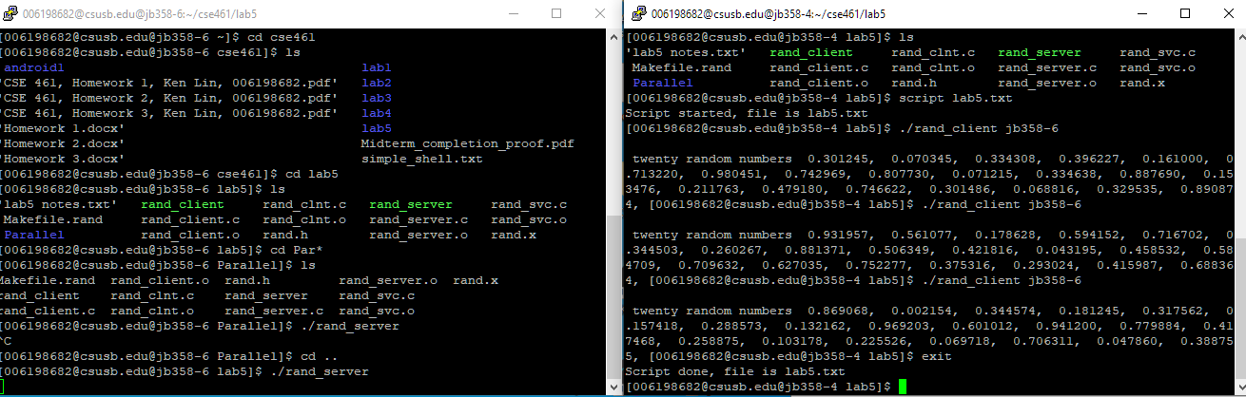

Screenshot of client and server running simultaneously.

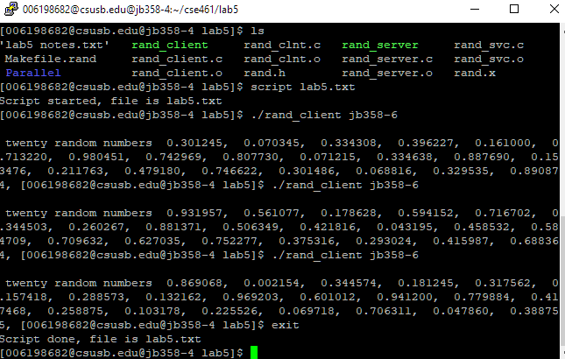

Client by itself.

Script File:

Lab5.txt (Script of me running the client program.)

|  |  |  |  |  |
| --- | --- | --- | --- | --- |
| Script started on 2020-06-02 23:34:46-07:00 [TERM="xterm" TTY="/dev/pts/0" COLUMNS="80" LINES="24"]  ]0;006198682@csusb.edu@jb358-4:~/cse461/lab5 | [006198682@csusb.edu@jb358-4 lab5]$ ./rand_client jb[K[K[K[Kt jb358-6  twenty random numbers 0.301245, 0.070345, 0.334308, 0.396227, 0.161000, 0.713220, 0.980451, 0.742969, 0.807730, 0.071215, 0.334638, 0.887690, 0.153476, 0.211763, 0.479180, 0.746622, 0.301486, 0.068816, 0.329535, 0.890874, ]0;006198682@csusb.edu@jb358-4:~/cse461/lab5 | [006198682@csusb.edu@jb358-4 lab5]$ ./rand_client jb358-6  twenty random numbers 0.931957, 0.561077, 0.178628, 0.594152, 0.716702, 0.344503, 0.260267, 0.881371, 0.506349, 0.421816, 0.043195, 0.458532, 0.584709, 0.709632, 0.627035, 0.752277, 0.375316, 0.293024, 0.415987, 0.688364, ]0;006198682@csusb.edu@jb358-4:~/cse461/lab5 | [006198682@csusb.edu@jb358-4 lab5]$ ./rand_client jb358-6  twenty random numbers 0.869068, 0.002154, 0.344574, 0.181245, 0.317562, 0.157418, 0.288573, 0.132162, 0.969203, 0.601012, 0.941200, 0.779884, 0.417468, 0.258875, 0.103178, 0.225526, 0.069718, 0.706311, 0.047860, 0.388755, ]0;006198682@csusb.edu@jb358-4:~/cse461/lab5 | [006198682@csusb.edu@jb358-4 lab5]$ exit  Script done on 2020-06-02 23:35:15-07:00 [COMMAND_EXIT_CODE="0"] |

**Source Code:**

Rand.x:

(Identical for this and part 9)

|  |
| --- |
| /* rand.x */  program RAND_PROG {  version RAND_VERS {  void INITIALIZE_RANDOM ( long ) = 1; /* service #1 */  double GET_NEXT_RANDOM ( void ) = 2; /* service #2 */  } = 1;  } = 6198682; /* program # */ |

Rand_client.c:

|  |
| --- |
| /*  * This is sample code generated by rpcgen.  * These are only templates and you can use them  * as a guideline for developing your own functions.  */  #include "rand.h"  double  rand_prog_1(char *host)  {  CLIENT *clnt;  void *result_1;  long initialize_random_1_arg;  double *result_2;  char *get_next_random_1_arg;  #ifndef DEBUG  clnt = clnt_create (host, RAND_PROG, RAND_VERS, "udp");  if (clnt == NULL) {  clnt_pcreateerror (host);  exit (1);  }  #endif /* DEBUG */  result_1 = initialize_random_1(&initialize_random_1_arg, clnt);  if (result_1 == (void *) NULL) {  clnt_perror (clnt, "call failed");  }  result_2 = get_next_random_1((void*)&get_next_random_1_arg, clnt);  if (result_2 == (double *) NULL) {  clnt_perror (clnt, "call failed");  }  #ifndef DEBUG  clnt_destroy (clnt);  #endif /* DEBUG */  return *result_2;  }  int  main (int argc, char *argv[])  {  char *host;  if (argc < 2) {  printf ("usage: %s server_host\n", argv[0]);  exit (1);  }  host = argv[1];  rand_prog_1 (host);  double x;  int i;  printf("\n twenty random numbers ");  for ( i = 0; i < 20; ++i ){  x = rand_prog_1 (host);  printf(" %f, ", x );  }  exit (0);  } |

rand_server.c:

|  |
| --- |
| /*  * This is sample code generated by rpcgen.  * These are only templates and you can use them  * as a guideline for developing your own functions.  */  #include "rand.h"  #include <stdio.h>  #include <stdlib.h>  #include <time.h>  int seed = 0;  void *  initialize_random_1_svc(long *argp, struct svc_req *rqstp)  {  static char * result;  seed += time(0) + 1; //we need to change the seed every time this is called  srand((unsigned) seed);  return (void *) &result;  }  double *  get_next_random_1_svc(void *argp, struct svc_req *rqstp)  {  static double result;  result = (double)rand()/RAND_MAX*1.0;  return &result;  } |

Makefile.rand: (Has -ltirpc in LDLIBS)

|  |
| --- |
| # This is a template Makefile generated by rpcgen  # Parameters  CLIENT = rand_client  SERVER = rand_server  SOURCES_CLNT.c =  SOURCES_CLNT.h =  SOURCES_SVC.c =  SOURCES_SVC.h =  SOURCES.x = rand.x  TARGETS_SVC.c = rand_svc.c rand_server.c  TARGETS_CLNT.c = rand_clnt.c rand_client.c  TARGETS = rand.h rand_clnt.c rand_svc.c rand_client.c rand_server.c  OBJECTS_CLNT = $(SOURCES_CLNT.c:%.c=%.o) $(TARGETS_CLNT.c:%.c=%.o)  OBJECTS_SVC = $(SOURCES_SVC.c:%.c=%.o) $(TARGETS_SVC.c:%.c=%.o)  # Compiler flags  CFLAGS += -g  LDLIBS += -lnsl -ltirpc  RPCGENFLAGS =  # Targets  all : $(CLIENT) $(SERVER)  $(TARGETS) : $(SOURCES.x)  rpcgen $(RPCGENFLAGS) $(SOURCES.x)  $(OBJECTS_CLNT) : $(SOURCES_CLNT.c) $(SOURCES_CLNT.h) $(TARGETS_CLNT.c)  $(OBJECTS_SVC) : $(SOURCES_SVC.c) $(SOURCES_SVC.h) $(TARGETS_SVC.c)  $(CLIENT) : $(OBJECTS_CLNT)  $(LINK.c) -o $(CLIENT) $(OBJECTS_CLNT) $(LDLIBS)  $(SERVER) : $(OBJECTS_SVC)  $(LINK.c) -o $(SERVER) $(OBJECTS_SVC) $(LDLIBS)  clean:  $(RM) core $(TARGETS) $(OBJECTS_CLNT) $(OBJECTS_SVC) $(CLIENT) $(SERVER) |

Part 9: (9 points assumed)

Parallel RNG

Screenshots:

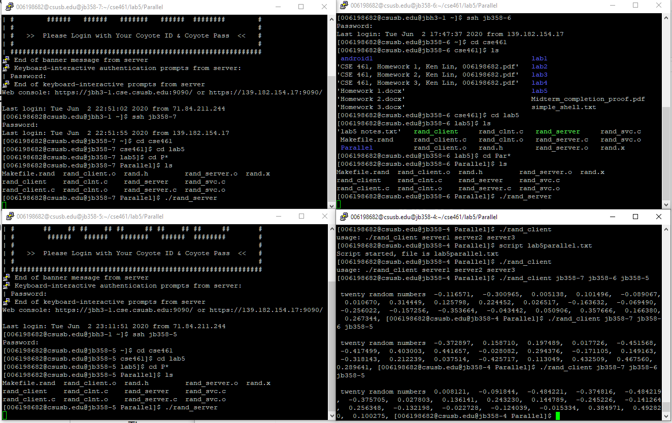

Screenshot of all 3 servers + client running simultaneously, and also the client obtaining results.

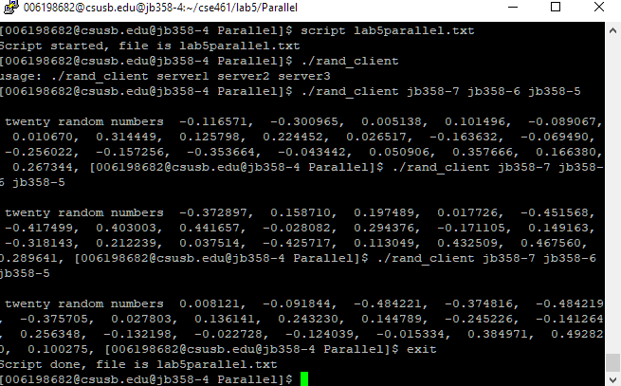

Screenshot of client by itself.

Script file:

Of me running the client. (Servers were all initialized via ./rand_server)

lab5parallel.txt

|  |  |  |  |  |  |
| --- | --- | --- | --- | --- | --- |
| Script started on 2020-06-02 23:22:51-07:00 [TERM="xterm" TTY="/dev/pts/0" COLUMNS="80" LINES="24"]  ]0;006198682@csusb.edu@jb358-4:~/cse461/lab5/Parallel | [006198682@csusb.edu@jb358-4 Parallel]$ ./rand_client  usage: ./rand_client server1 server2 server3  ]0;006198682@csusb.edu@jb358-4:~/cse461/lab5/Parallel | [006198682@csusb.edu@jb358-4 Parallel]$ ./rand_client jb358-7 jb358-6 jb358-5  twenty random numbers -0.116571, -0.300965, 0.005138, 0.101496, -0.089067, 0.010670, 0.314449, 0.125798, 0.224452, 0.026517, -0.163632, -0.069490, -0.256022, -0.157256, -0.353664, -0.043442, 0.050906, 0.357666, 0.166380, 0.267344, ]0;006198682@csusb.edu@jb358-4:~/cse461/lab5/Parallel | [006198682@csusb.edu@jb358-4 Parallel]$ ./rand_client jb358-7 jb358-6 jb358-5  twenty random numbers -0.372897, 0.158710, 0.197489, 0.017726, -0.451568, -0.417499, 0.403003, 0.441657, -0.028082, 0.294376, -0.171105, 0.149163, -0.318143, 0.212239, 0.037514, -0.425717, 0.113049, 0.432509, 0.467560, 0.289641, ]0;006198682@csusb.edu@jb358-4:~/cse461/lab5/Parallel | [006198682@csusb.edu@jb358-4 Parallel]$ ./rand_client jb358-7 jb358-6 jb358-5  twenty random numbers 0.008121, -0.091844, -0.484221, -0.374816, -0.484219, -0.375705, 0.027803, 0.136141, 0.243230, 0.144789, -0.245226, -0.141264, 0.256348, -0.132198, -0.022728, -0.124039, -0.015334, 0.384971, 0.492820, 0.100275, ]0;006198682@csusb.edu@jb358-4:~/cse461/lab5/Parallel | [006198682@csusb.edu@jb358-4 Parallel]$ [Kexit  Script done on 2020-06-02 23:24:26-07:00 [COMMAND_EXIT_CODE="0"] |

Source Code:

Makefile.rand:

(Needed to edit this to enable math library functions.)

|  |
| --- |
| # This is a template Makefile generated by rpcgen  # Parameters  CLIENT = rand_client  SERVER = rand_server  SOURCES_CLNT.c =  SOURCES_CLNT.h =  SOURCES_SVC.c =  SOURCES_SVC.h =  SOURCES.x = rand.x  TARGETS_SVC.c = rand_svc.c rand_server.c  TARGETS_CLNT.c = rand_clnt.c rand_client.c  TARGETS = rand.h rand_clnt.c rand_svc.c rand_client.c rand_server.c  OBJECTS_CLNT = $(SOURCES_CLNT.c:%.c=%.o) $(TARGETS_CLNT.c:%.c=%.o)  OBJECTS_SVC = $(SOURCES_SVC.c:%.c=%.o) $(TARGETS_SVC.c:%.c=%.o)  # Compiler flags  CFLAGS += -g  LDLIBS += -lnsl -ltirpc -lm  RPCGENFLAGS =  # Targets  all : $(CLIENT) $(SERVER)  $(TARGETS) : $(SOURCES.x)  rpcgen $(RPCGENFLAGS) $(SOURCES.x)  $(OBJECTS_CLNT) : $(SOURCES_CLNT.c) $(SOURCES_CLNT.h) $(TARGETS_CLNT.c)  $(OBJECTS_SVC) : $(SOURCES_SVC.c) $(SOURCES_SVC.h) $(TARGETS_SVC.c)  $(CLIENT) : $(OBJECTS_CLNT)  $(LINK.c) -o $(CLIENT) $(OBJECTS_CLNT) $(LDLIBS)  $(SERVER) : $(OBJECTS_SVC)  $(LINK.c) -o $(SERVER) $(OBJECTS_SVC) $(LDLIBS)  clean:  $(RM) core $(TARGETS) $(OBJECTS_CLNT) $(OBJECTS_SVC) $(CLIENT) $(SERVER) |

Rand_clnt.c:

(Needed to edit this because client now sends two doubles to the server during the RPC.)

|  |
| --- |
| /*  * Please do not edit this file.  * It was generated using rpcgen.  */  #include <memory.h> /* for memset */  #include "rand.h"  /* Default timeout can be changed using clnt_control() */  static struct timeval TIMEOUT = { 25, 0 };  void *  initialize_random_1(long *argp, CLIENT *clnt)  {  static char clnt_res;  memset((char *)&clnt_res, 0, sizeof(clnt_res));  if (clnt_call (clnt, INITIALIZE_RANDOM,  (xdrproc_t) xdr_long, (caddr_t) argp,  (xdrproc_t) xdr_void, (caddr_t) &clnt_res,  TIMEOUT) != RPC_SUCCESS) {  return (NULL);  }  return ((void *)&clnt_res);  }  double *  get_next_random_1(void *argp, CLIENT *clnt, double *x1, double *x2)  {  static double clnt_res;  memset((char *)&clnt_res, 0, sizeof(clnt_res));  if (clnt_call (clnt, GET_NEXT_RANDOM,  (xdrproc_t) xdr_void, (caddr_t) argp,  (xdrproc_t) xdr_double, (caddr_t) &clnt_res,  TIMEOUT) != RPC_SUCCESS) {  return (NULL);  }  return (&clnt_res);  } |

Rand.h:

(Same reason as above)

|  |
| --- |
| /*  * Please do not edit this file.  * It was generated using rpcgen.  */  #ifndef _RAND_H_RPCGEN  #define _RAND_H_RPCGEN  #include <rpc/rpc.h>  #ifdef __cplusplus  extern "C" {  #endif  #define RAND_PROG 6198682  #define RAND_VERS 1  #if defined(__STDC__) || defined(__cplusplus)  #define INITIALIZE_RANDOM 1  extern void * initialize_random_1(long *, CLIENT *);  extern void * initialize_random_1_svc(long *, struct svc_req *);  #define GET_NEXT_RANDOM 2  extern double * get_next_random_1(void *, CLIENT *, double *, double *);  extern double * get_next_random_1_svc(void *, struct svc_req *, double *, double *);  extern int rand_prog_1_freeresult (SVCXPRT *, xdrproc_t, caddr_t);  #else /* K&R C */  #define INITIALIZE_RANDOM 1  extern void * initialize_random_1();  extern void * initialize_random_1_svc();  #define GET_NEXT_RANDOM 2  extern double * get_next_random_1();  extern double * get_next_random_1_svc();  extern int rand_prog_1_freeresult ();  #endif /* K&R C */  #ifdef __cplusplus  }  #endif  #endif /* !_RAND_H_RPCGEN */ |

Rand_server.c:

(First of the ‘proper’ source code files)

|  |
| --- |
| /*  * This is sample code generated by rpcgen.  * These are only templates and you can use them  * as a guideline for developing your own functions.  */  #include "rand.h"  #include <stdio.h>  #include <stdlib.h>  #include <time.h>  #include <math.h>  int seed = 0;  void *  initialize_random_1_svc(long *argp, struct svc_req *rqstp)  {  static char * result;  seed += time(0) + 1; //we need to change the seed every time this is called  srand((unsigned) seed);  return (void *) &result;  }  double *  get_next_random_1_svc(void *argp, struct svc_req *rqstp, double *x1, double *x2)  {  //to compute a random number with 3 servers, take as input two doubles  //from up to two other machines  //and return a random number generated here, plus the other two, modulo 1  //That is, result = (random + x1 + x2) % 1  //note that the distribution of number for this probably isn't uniform  //that is, certain numbers should be more likely than others  static double result;  result = (double)rand()/RAND_MAX*1.0;  result = remainder((result + *x1 + *x2), 1.0); //can't use modulus directly  return &result;  } |

Rand_client.c:

(Lots of modifications to handle passing doubles to server & handling 3 servers.)

|  |
| --- |
| /*  * This is sample code generated by rpcgen.  * These are only templates and you can use them  * as a guideline for developing your own functions.  */  #include "rand.h"  double  rand_prog_1(char *host1, char *host2, char *host3)  {  CLIENT *clnt1;  CLIENT *clnt2;  CLIENT *clnt3;    void *result_1;  long initialize_random_1_arg;  double *result_2;  char *get_next_random_1_arg;  double l, m;  l = 0.0;  m = 0.0;  double *temp_1 = &l;  double *temp_2 = &m;  #ifndef DEBUG  clnt1 = clnt_create (host1, RAND_PROG, RAND_VERS, "udp");  if (clnt1 == NULL) {  clnt_pcreateerror (host1);  exit (1);  }    clnt2 = clnt_create (host2, RAND_PROG, RAND_VERS, "udp");  if (clnt2 == NULL) {  clnt_pcreateerror (host2);  exit (1);  }    clnt3 = clnt_create (host3, RAND_PROG, RAND_VERS, "udp");  if (clnt3 == NULL) {  clnt_pcreateerror (host3);  exit (1);  }  #endif /* DEBUG */  result_1 = initialize_random_1(&initialize_random_1_arg, clnt1);  if (result_1 == (void *) NULL) {  clnt_perror (clnt1, "call failed");  }    result_1 = initialize_random_1(&initialize_random_1_arg, clnt2);  if (result_1 == (void *) NULL) {  clnt_perror (clnt2, "call failed");  }    result_1 = initialize_random_1(&initialize_random_1_arg, clnt3);  if (result_1 == (void *) NULL) {  clnt_perror (clnt3, "call failed");  }    //not quite fully parallel because the client doesn't store earlier results  //so instead what's happening is that server1 generates a random number by itself  temp_1 = get_next_random_1((void*)&get_next_random_1_arg, clnt1, temp_1, temp_2);  if (temp_1 == (double *) NULL) {  clnt_perror (clnt2, "call failed");  }    //server 2 generates a number from the results of server 1 and itself  temp_2 = get_next_random_1((void*)&get_next_random_1_arg, clnt2, temp_1, temp_2);  if (temp_2 == (double *) NULL) {  clnt_perror (clnt3, "call failed");  }    //and server three generates a number from server 1, 2, and itself  result_2 = get_next_random_1((void*)&get_next_random_1_arg, clnt3, temp_1, temp_2);  if (result_2 == (double *) NULL) {  clnt_perror (clnt3, "call failed");  }      #ifndef DEBUG  clnt_destroy (clnt1);  clnt_destroy (clnt2);  clnt_destroy (clnt3);  #endif /* DEBUG */  return *result_2;  }  int  main (int argc, char *argv[])  {  char *host1;  char *host2;  char *host3;  if (argc != 4) {  //client needs to connect to three servers  printf ("usage: %s server1 server2 server3\n", argv[0]);  exit (1);  }  host1 = argv[1];  host2 = argv[2];  host3 = argv[3];    rand_prog_1 (host1, host2, host3);  double x;  int i;  printf("\n twenty random numbers ");  for ( i = 0; i < 20; ++i ){  x = rand_prog_1 (host1, host2, host3);  printf(" %f, ", x );  }  exit (0);  } |